Current Research on Leadership Development
Insider Threat Awareness and Mitigation Training

Earl Newell Crane

Submission Date: July 8, 2007

Copyright © 2007 Earl Crane

Application Component Abstract
The application component contains training content for an insider threat awareness program. This material was combined with the breadth and depth components to create a one hour presentation, delivered to system owners and information security managers. The awareness program provides background information to the issues of trust, technology adoption, and insider threat. It concludes with a set of thirteen recommendations for managers to reduce the risk of insider threat, compiled by Carnegie Mellon.
Table of Contents
Application Component Abstract 2
Trust 4
Trust and Information Systems 5
Trust and the TAM 8
Insider Threat 9
Profiling and the Critical Pathway 10
Insider Threat Mitigation 13
Criminal Theory 15
General Deterrence Theory 15
Social Bond Theory 16
Social Learning Theory 17
Theory of Planned Behavior 18
Situational Crime Prevention 19
Insider Threat Prediction and Monitoring Tools 19
Insider Threat Control Recommendations 21
Practice 1: Institute periodic enterprise-wide risk assessments 21
Practice 2: Institute periodic security awareness training for all employees 22
Practice 3: Enforce separation of duties and least privilege 23
Practice 4: Implement strict password and account management policies and practices 24
Practice 5: Log, monitor, and audit employee online actions 24
Practice 6: Use extra caution with system administrators and privileged users 25
Practice 7: Actively defend against malicious code 26
Practice 8: Use layered defense against remote attacks 27
Practice 9: Monitor and respond to suspicious or disruptive behavior 27
Practice 10: Deactivate computer access following termination 28
Practice 11: Collect and save data for use in investigations 28
Practice 12: Implement secure backup and recovery processes 29
Practice 13: Clearly document insider threat controls 29
Future Work: Information security in a collaboration environment 30
Conclusion 33

Introduction
In the Breadth component this paper addressed the foundational aspects of trust, including societal based trust, team based trust, and individual trust. This overview of trust characteristics provided a foundation for one of the core aspects of trust in the depth sequence, insider threat and technology adoption. Insider threat and technology adoption are not often thought of as having trust components, but as the depth component demonstrated, insider threats come from trusted individuals, and organizations often fall into the “trust trap”. Technology adoption is also influenced by trust users have in an information system and other users of that information system. This builds towards the final application component of this paper, which is a training program to make managers and organizations aware of the insider threat problem, how trust is a factor, and how technology adoption both contribute to and mitigate the insider threat.

As discussed in the breadth component, trust is a key aspect in organizational leadership. This paper addresses the leadership requirement in KAM V by addressing trust aspects throughout the management spectrum, from abstract trust and team building to specific trust in the insider threat problem. The application component provides the most current research and solutions to address the insider threat problem, from a management, operational, and technical standpoint.

Trust
Trust relates to insider threat through two mechanisms. First, individuals trust information systems to share information, but which can also be used by insiders to gather information. Legitimate users can adopt additional technology controls to reduce the impact of malicious insiders through compartmentalization. Second, organizations and employees fall into the “trust trap”, where users begin to trust the insider more, allowing them to take larger risks to conduct their malicious activity.

Trust and Information Systems
In the Breadth Component this paper broke trust into three categories, interpersonal trust, team trust, and societal trust. The foundation for interpersonal trust dated back to feudal times, when patrons and clients relied on each other for support and survival, as Eisenstadt described. (Eisenstadt & Roniger, 1984) Interpersonal trust evolved to team trust, which was captured by several modern-day authors and is used in current management theory. Ken Blanchard provides a situational leadership model, where the follower evolves along a “development continuum”, which requires the leader to progress through four phases of leadership, directing, coaching, supporting, and delegating. (Blanchard, Fowler, & Hawkins, 2005) Finally, the Breadth Component addressed societal trust, addressing trust in a group of people that has adopted norms and accepted behavior. This is analogous to a large corporation with a corporate culture. This is also analogous to trust across a virtual community, where the authors explore how trust in a virtual environment has many of the same drivers as trust in a traditional environment. Gibson discusses the importance of maintaining regular communications as a mechanism to build trust in virtual environments. Gibson points out that while this is a factor in traditional environments, fewer opportunities for trust building exist in virtual environments, so the remaining trust building factors play a larger role. (Gibson, 2003)

Several authors address trust as it applies to abstract systems. Adam Seligman states “Trust in abstract systems provides for the security of day-to-day reliability, but by its very nature cannot supply either the mutuality or the intimacy which personal trust relations offer.” (Seligman, 1997, p. 17) Seligman demonstrates a disconnect between traditional interpersonal trust and the trust we use to address abstract systems, such as information systems. He also addresses the difference between trust in a system and confidence in the correct operation of a system, and their distinct differences. This is also addressed as operational correctness or trusted computing, which addresses the correct operating of an information system.

The Depth Component takes Seligman’s abstract trust theories and applies them to the topic of trust and information systems. The Depth Component this KAM addresses the issue of trust, technology adoption, and insider threat. Specifically trust as a factor in mitigating the insider threat, influencing the technology adoption process. Several important distinctions arise during this process, where some researchers see trust in regards to building bonds and relationships between people through information systems, such as “Trust Cues” which are used to build trust factors both online and offline, crossing the boundary between domains. From website design to recommender systems, typographical errors to transaction ratings, a multitude of trust cues affect the creation or destruction of trust, to encourage or discourage the trustor from trusting. (Corritore, Kracher, & Wiedenbeck, 2003)
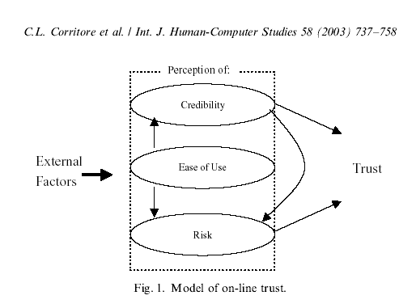
Figure 1. (Corritore, Kracher, & Wiedenbeck, 2003)
Others take a different approach, where the trust of an information system translates to the trust of an individual. This continuum of trust is discussed by Chopra and Wallace (2003) as they identify trust in online relationships. Chopra and Wallace (2003) propose trust in information systems has two perspectives, interpersonal trust for specific systems, and societal trust for large networks, such as enterprise information systems. This follows the distinction made in the Breadth Component, where Eisenstadt, Luhmann, and Pettit discuss interpersonal trust, while Fukuyama, Gibson, Seligman and Urban discuss societal trust. Chopra and Wallace also make the distinction that trust in information is not the same type of trust as interpersonal trust, but a trust in the “proper functioning of computer hardware and software”. (Chopra & Wallace, 2003, p. 7)

Trust in online relationships grow in a similar manner to real-world relationships, where it grows stronger based on previous interactions. This type of trust closely follows the interpersonal model of trust. (Chopra & Wallace, 2003, p. 8) This situation may be a person engaged in a chat room, bulletin board, email, or other electronic communication resource for sharing information.

Trust and the TAM
As discussed in the Depth Component, the Technology Acceptance Model (TAM) provides a mechanism to model technology adoption, using Perceived Ease of use (PEOU) and Perceived Usefulness (PU). However, this does not account for trust factors in adopting the use of an information system. Several authors have looked at integrating the TAM with trust, but none have used it to address insider threat. (Hampton-Sosa & Koufaris, 2005) (Hsi-Peng, Chin-Lung, & Hsiu-Ying, 2005) (Suh & Han, 2002) For example, Sun and Han modify the TAM to address technology adoption.
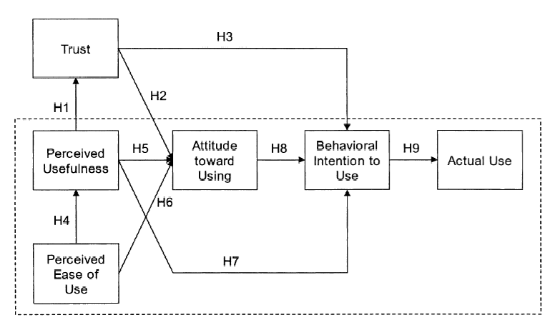
Figure 2. (Suh & Han, 2002)
An interesting component of trust of trust is knowing what you know, and knowing what you don’t know. This is addressed by Komiak and Benbasat in their paper comparing cognitive trust and emotional trust. Awareness of the known directly affects cognitive trust (a), and may affect emotional trust either directly (b) or indirectly through cognitive trust. Awareness of the unknown will most likely affect both emotional trust and cognitive trust, decreasing trust in both. Customers may feel less in control, less certain, less secure and less comfortable about their situation. (Komiak & Benbasat, 2004, p. 188)
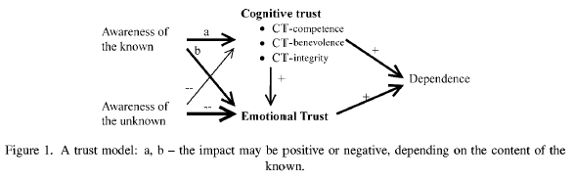
Figure 3. (Komiak & Benbasat, 2004)
A background in trust and technology adoption is critical to understanding and mitigating the threat of malicious insiders. Insiders today use information systems to pilfer sensitive information, and trust is a factor both in the access they gain and the controls to mitigate this threat.

Insider Threat
The Depth Component introduced the threat of malicious insiders, now the application component discusses mitigating activities. The application component is intended to be a training and awareness program for security managers, which requires a background understanding in trust and technology adoption. So far we have addressed trust and technology adoption, this section will address controls to identify and mitigate their attack.

Profiling and the Critical Pathway
Insider threat mitigation includes both the policies and practices affecting employment screening, and to deter employee actions upon hiring. Though a reliable profile is difficult to identify, Shaw and Fischer authors put forward a concept of the “critical pathway”, a mechanism to identify the likelihood of an insider attack through analysis of at-risk characteristics. The critical pathway is meant to capture the insider’s characteristics, stressors, and interactions to determine a profile and establish a mechanism to identify increased risk. The critical pathway is very similar to system dynamics, though on a less complex scale.
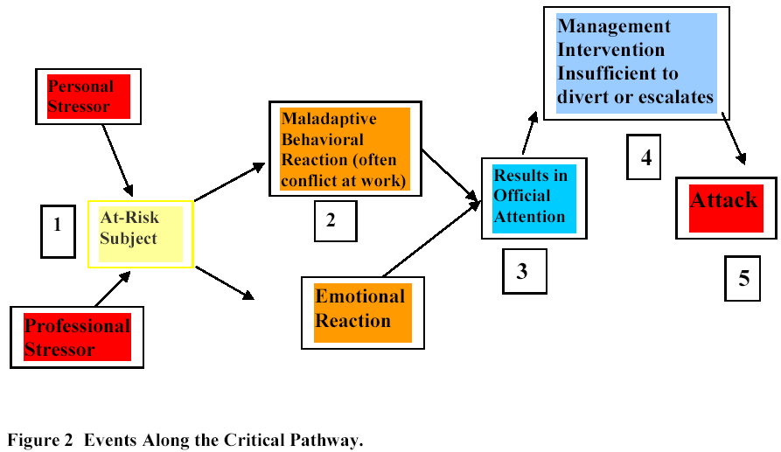
Figure 4. (Shaw & Fischer, 2005)

Shaw and Fischer focus on two recommendations that can reduce the number of successful malicious insider attacks. They state that managers should review and enforce policies regarding termination procedures and remote access policies. The authors discovered significant delays in corrective management actions to address personnel issues. In some cases, such as The Thief, the supervisor was aware of general disgruntlement but not the source, mostly due to a lack of communication. As the supervisor intervened with The Thief, the discipline only further aggravated him, though he did not communicate the specific cause to his supervisor. In fact, the authors state “One of the most important findings of this research was that there was a window of opportunity for dealing with the personnel problems affecting these subjects.” (Shaw & Fischer, 2005, p. 41) Figure 5 provides an overview of disgruntlement for the 10 cases, and demonstrates the specific window of opportunity:

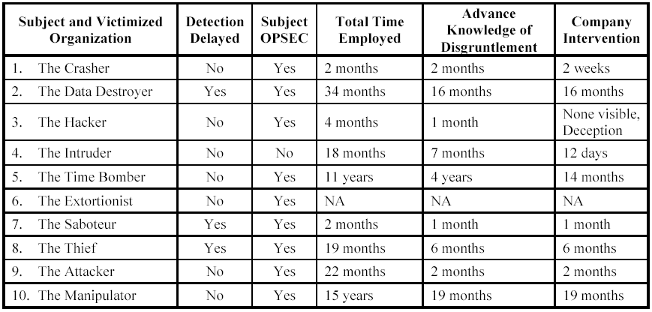
Figure 5. (Shaw & Fischer, 2005, p. 13)

The authors also discuss termination, and how termination can influence insider’s decisions when choosing their action. In some cases users are still permitted remote access in to corporate resources after termination, in other cases they have been allowed to continue to use company services as a customer, thus enabling their continued insider activity. Other cases show that psychological issues with terminated employees may prompt malicious insider activity. If the organization was aware of ongoing psychological problems, appropriate steps could have been taken to possibly prevent the insider attack. Termination practices played a critical factor in 8 of the 10 cases reviewed. Figure 6 shows the length of time between termination and incident, showing there is no clear pattern of time period. (Shaw & Fischer, 2005, p. 18)

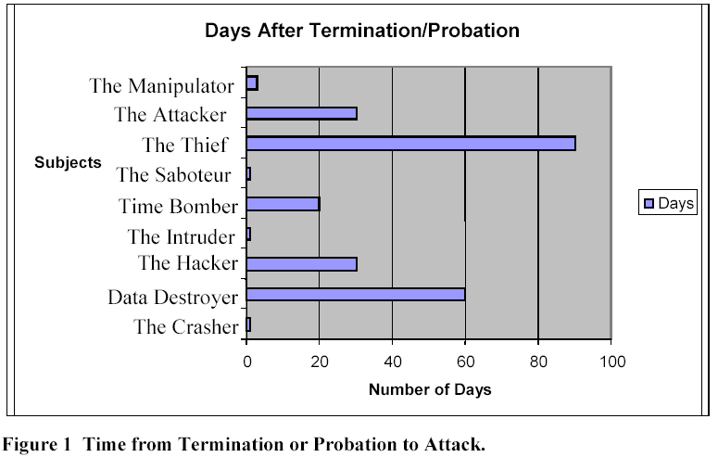
Figure 6. (Shaw & Fischer, 2005, p. 18)

The authors also demonstrate that attackers tend to make use of systems they are familiar with. They may use familiar systems both as the target of attack, or as an intermediary hop to their true target. This demonstrates an increased risk to information systems by users familiar with the information system. As individuals are more likely to use or abuse the systems they most closely associate, those are the systems they may be more likely to harm. Consider that when allowing interconnections across organizations, that targeted applications may not be the critical ones the application owner has in mind.

Insider Threat Mitigation
In the Depth Component this paper addressed the trust trap, and how organizations can fall into a cycle of trusting an insider and providing them additional leeway to let them continue their malicious insider activity. Part of this is blamed on the lack of management controls and awareness, which is addressed later in this paper, and part is addressed due to a lack of awareness and a culture of security throughout an organization.

Adams and Sasse (1999) identify a disconnect between the user community and the IT department, one of distrust and miscommunication that drives password security towards insecurity, self reinforcing much like the “trust trap”, but in an insecure direction. (Anderson et al., 2004) Users tended to perceive their insecure behavior as a forced response to security controls, such as requiring password changes, complex passwords, or multiple passwords. As a result users began to reuse passwords, share passwords, and write passwords down. In some cases users specifically had trouble remembering passwords due to change requirements, when they would modify their previous password only slightly. Retention and recall was decreased due to increased within-list interference. (Adams & Sasse, 1999, p. 42) Another misunderstanding between the users and the IT department was the prevalence of threats. Users consistently did not recognize the value of the information they processed, often rating email and personal records above financial systems and human resources information. Therefore concerns over password cracking or misuse became more of a personal problem than an IT problem.

Adams and Sasse recognized the common practice of information restriction and compartmentalization work well in “military organizations”, but “limits usable solutions to the security problems of modern organizations seeking to encourage work practices such as teamwork and shared responsibility. Such organizations require support for trust and information sharing.” (Adams & Sasse, 1999, p. 44) While IT and security departments understand the information threats, users often do not, and are at a loss to understand why the IT departments operate with such restrictive measures. The authors specifically cite the FIPS guidance for password use, but state it works on an underlying assumption that users understand the value of keeping information confidential, which is not always a perception held by all users, including those processing sensitive information. The authors conclude with two findings about IT departments and users: 1. Users lack security awareness, and 2. security departments lack knowledge about users. This lack of knowledge and communication continues to drive the trust trap towards greater distrust. As users are required to adhere to stricter security policies, they are more likely to circumvent those security controls for convenience.

Criminal Theory
Preventing insider attacks is similar to preventing other types of criminal incidents, and are discussed by Theoharidoua, et al. (2005). The authors provide an overview of criminal theory, including deterrence theory, and the models used to evaluate criminal mindsets and prevention mechanisms. The authors posit that since criminal elements have been integrated into security management terminology, such as computer crime, computers abuse and misuse, motives and deterrence, that criminology theories can also be applicable to address computer crime. (Theoharidoua, Kokolakisb, Karydaa, & Kiountouzisa, 2005, p. 474) The five theories applicable to cybercrime and insider threat include General Deterrence Theory, Social Bond Theory, Social Learning Theory, Theory of Planned Behavior, and Situational Crime Prevention.

General Deterrence Theory
General Deterrence Theory (GDT) is one of the oldest criminal theories, based on a foundation of minimizing cost while maximizing returns. This theory suggests that if the possibility of punishment is likely and the punishment is harsh, criminals will be deterred from the action, especially if their motives are weak. This is more applicable to white collar crimes where individuals usually conform to rules and regulations.

Theoharidoua, et al. cite the application of this criminal theory in the information security arena, called the Security Action Cycle. This model suggests four stages of computer abuse, where the goal is to increase stages one and two, and decrease incidents in stages three and four:
- Deterrence – prevention through security policies and procedures
- Prevention – physical or procedural controls
- Detection – alarming staff to possible abuse
- Remedies – consequences take on offender and updated controls
(Theoharidoua, Kokolakisb, Karydaa, & Kiountouzisa, 2005, p. 474)

This falls in line with a recommendation by the US Department of Defense Information Systems, which recommends increasing employees’ awareness and accountability by publicizing the consequences of misuse, abuse, and malicious activity. It also recommends publicizing the measures taken to prevent or detect that abuse.

Social Bond Theory
Social Bond Theory (SBT) is a popular theory in criminology, which identifies four types of social bonds in place to reduce the likelihood that an individual will perform a criminal act. These social bonds deter them due to influences in their environment or possible consequences in their social circle. Hence, weaker social bonds may increase the likelihood of criminal activity. The four social bonds are:
- Attachment – an individual’s social surroundings, including norms and conscience. Important social institutions include school, family, and peers.
- Commitment – people who invest time and energy to conform to social norms, such as education, property, or reputation, are less likely to risk losing these achievements through criminal activity.
- Involvement – those who participate in conventional activities in school, work, family, or recreation may have less time available to participate in criminal activity.
- Beliefs – those with weak or absent social values may be more likely to engage in antisocial acts.
The personality traits of SBT are evident in the personality traits identified in those who have committed cyber crimes, such as the lack of normal social values or activities. Other studies cited also discussed the combination of both SBT and GDT in preventing insider threats. (Theoharidoua, Kokolakisb, Karydaa, & Kiountouzisa, 2005, p. 475)

Social Learning Theory
Social Learning Theory (SLT) relies on association and reinforcement, whereby a person will commit a crime because they have been associated with a delinquent group, who transmit delinquent ideas, and reinforce delinquent behavior through role models. This model has four constructs to capture delinquent behavior:
- Differential Association – exposed to definitions and ideas that support criminal behavior
- Differential reinforcement/punishment – a balance between reward and punishment is judged to support criminal behavior
- Definition of behavior – rationalization of a criminal act as right or wrong
- Imitation – engage in criminal activity after observing others
This model suggests employees are influenced by coworkers and superiors, which also suggests a remedy to use others to influence them and discourage insiders from carrying out malicious behavior.
(Theoharidoua, Kokolakisb, Karydaa, & Kiountouzisa, 2005, p. 476)

Theory of Planned Behavior
Theory of Planned Behavior (TPB) is one of the most popular and influential conceptual frameworks for the study of human behavior. The basic assumption is that a person’s intention is a key factor to predict their behavior. Intentions are shaped by one of three factors:
- Attitude – Does a person favor a certain behavior, such as a criminal element? If they perceive the result of a behavior as positive, they are more likely to engage in that behavior.
- Subjective norms – The individual’s social environment exerts social pressures for or against certain behavior. If the social environment considers a certain behavior to be positive, the individual is more likely to support the behavior. This action is also supported by Gallivan (2001) where mandated adoption is influenced by pressures from their social environment.
- Perceived behavioral control – A person molds their intentions to perform a behavior based on the difficulty of performing the behavior, and their ability to execute the behavior successfully. If they believe the behavior is something within their control to execute, they are more likely to exhibit that behavior.
The application of TPB to insider threats suggests social bonds affect individual’s behaviors, social learning affects the subjective norms they hold, and general deterrence factors create the perceived behavioral control.
(Theoharidoua, Kokolakisb, Karydaa, & Kiountouzisa, 2005, p. 476)

Situational Crime Prevention
Situational Crime Prevention (SCP) is based on the theory that to commit a crime, a person must have the motive and the opportunity. By reducing available opportunities, we can reduce the occurrence of crime. This can be done in one of four ways:
- Make the criminal act appear more difficult, by requiring increased effort.
- Make the criminal act appear more dangerous, meaning it is more likely to be detected.
- Reduce the benefit a person receives by removing the target or denying benefits.
- Remove the excuses a person makes to justify their actions.
(Theoharidoua, Kokolakisb, Karydaa, & Kiountouzisa, 2005, p. 476)
This section has addressed five criminology theories that are applicable to cybercrime and insider threat deterrence. The next section addresses insider threats and various monitoring tools.

Insider Threat Prediction and Monitoring Tools
Some effort has been made to create tools to aid managers in reducing insider threats through prediction, modeling, and monitoring online activities. However, Shaw & Fischer point out that in several of the insider attacks, their online activity was the first sign of any discontent, and at that point it is already too late. Any automated monitoring tool will most likely trigger once the malicious activity has been performed, and will most likely have a high rate of false positives. (Shaw & Fischer, 2005, p. 28)

The authors discuss the utility of monitoring tools to include psychological profiling algorithms, keywords, communication-characteristic matching, changes in psychological state, and alerting the appropriate individuals. While there are some common themes in the attacks, there is not one reliable profile on which to base an identification of potential malicious insiders. (Shaw & Fischer, 2005, p. 3)

Other authors have also proposed similar tools to predict the likelihood of insider attacks. (Magklaras & Furnell, 2001) In addition, authors have proposed tools such as the MoTEC model to predict and quantify the trust users will have in a particular website. (Egger, 2003) They suggest a new approach to dealing with insiders that misuse IT systems that identifies an insider taxonomy, classifying incidents in three dimensions: incident, response, and consequences. Magklaras & Furnell continue to further break these dimensions down to sub-categories. They conclude with a discussion of their proposed tool, an Insider Threat Prediction Tool, which is intended to identify possible insider threat actors based on certain activities. They make it clear this is primarily intended as a threat prediction tool, not a threat detection tool. (Magklaras & Furnell, 2001, p. 68) By operating as a threat prediction tool, the authors correlate organizational policy with behavior, embedding policy in the ITPT tool. (Magklaras & Furnell, 2001, p. 69)

Another simplistic model proposed to predict insider threat is based on CPU usage and RAM usage. (Magklaras & Furnell, 2005) This model assumes an IT savvy user will perform the insider threat. However, in application it will result in identifying all savvy IT users, including all system administrators. However, this is data we can get from HR records and interviews, and this model may misidentify other savvy users as likely insider threats, resulting in a higher false positive rate.

Insider Threat Control Recommendations
Cappelli, et al. proposes a set of thirteen recommendations to organizations to reduce the likelihood of a successful insider attack. These recommendations come from a study of the insider threat database, and include both technical and non-technical recommendations. (Cappelli, Moore, Shimeall, & Trzeciak, 2006)

This article has thirteen points that provide best practices for managers to protect their assets from malicious insiders. These thirteen recommendations can create the foundation of this paper discussing recommendations to prevent or safeguard against insider threats.

Practice 1: Institute periodic enterprise-wide risk assessments
This is the issue of enterprise trust, why some groups will not play with others in an enterprise environment. Performing an enterprise wide risk assessment allows management to capture a point-in-time and accurate picture of their organization’s assets, and the controls in place to safeguard those assets.

Cappelli, et al. point out that most organizations focus on external threats during a risk assessment, rather than malicious insiders. These may include business partners, partner organizations, employees, former employees, contractors, satellite offices, even customers allowed to process information at their site.

The other advantage to an enterprise risk assessment is that most organizations leave the responsibility to check and protect against malicious insiders with the insiders themselves, often those who may be most likely to perform the attack. When organizations do not acknowledge the potential risk of insider threats, or threats and vulnerabilities in general, the organization may compromise its ability to achieve its mission.

Practice 2: Institute periodic security awareness training for all employees
Information security awareness is critical to identifying malicious insiders – as many of their activities may go undetected by security controls.

Cappelli, et al. recognize there is no “profile” for an insider, they may be of any level in the organization and any education. From CEO to the janitor, malicious insiders take many forms, though all malicious insiders share common traits – they have a personality disposition that identifies their tendencies. Therefore all employees, especially managers, must have general awareness training to recognize common traits of malicious insiders. This training should cover how to recognize malicious insiders through behavior, not stereotypes. The training programs should create a culture of security and awareness, and make sense for the culture of the organization.

The training should be based on documented, reviewed, and approved policy that has been vetted through an organizational process. Ad-hoc policy without foundation in well-thought principles will lose credibility and become unenforceable. A critical component to documented policy is a confidential system to report potential insiders, observed by other employees.

Practice 3: Enforce separation of duties and least privilege
Separation of duties and the two-person rule is a foundational component of ensuring checks and balances exist in any system where power or authority is exhibited over users. These principles also require support of the least privilege principle, whereby users are not granted access beyond what is necessary for them to perform their job.

When a system of checks and balances is not in place, especially between management and system administration, the situation is primed for a malicious insider. One convicted malicious insider was quoted as saying it was like “the fox guarding the henhouse”, whereby no management component was reviewing and auditing his activity. (Cappelli, Moore, Shimeall, & Trzeciak, 2006, p. 22)

Practice 4: Implement strict password and account management policies and practices
Passwords are the first line of defense in most organizational information systems. It is for this need that dual-factor authentication has increased in popularity, especially for sensitive systems. However, more than just a stronger authentication mechanism is necessary to prevent malicious insiders. Password policies are necessary, and only useful when enforced. This is more than just password complexity, it also includes sharing passwords, disabling when an employee is terminated, and removing unknown, unused, or unrecognized passwords. After all, if an account that has not been used in six months is disabled, chances are the account user will not miss it, and probably doesn’t even know it exists.

Cappelli, et al. also considers that password cracking and strength testing may actually enable and help insiders, as they may be the individuals asked to perform this password audit. A password audit gives the insider a legitimate reason to audit for passwords. Instead, enforcing password complexity, lifetime, and history, combined with strong user education, will work to prevent weak passwords.

Practice 5: Log, monitor, and audit employee online actions
The purpose of logging and monitoring is to associate online actions with the employees who perform them. This assumes users are only using their assigned accounts, under Practice #4. Auditing can compare online and offline records to check for changes.

Auditing should occur on both a periodic and random basis. The IRS is cited as a great model to monitor, audit, and process large survey sizes with sampling patterns. This system works on flags. In addition, random audits may keep malicious insiders off-guard enough to dissuade them from attempting malicious actions.

One example of an insider used to change the financial records before each quarterly audits. This hid the insiders evidence of fraud, and it wasn’t discovered until much later during a bank audit. By this time over $500,000 was lost. Random audits would have increased the likelihood of discovering this insider earlier. (Cappelli, Moore, Shimeall, & Trzeciak, 2006, p. 25)

Practice 6: Use extra caution with system administrators and privileged users
Users with the highest level of technical ability and information access are particularly privileged to be in an opportunity to commit malicious actions. As a result their accounts must have extra monitoring and audit controls in place. Organizations should ensure user’s actions can be traced back, especially for those with privileged access.

One example cited by Cappelli, et al. had an administrator as a malicious insider. Suspicious management began logging the administrators actions to a separate, hidden log file. When the administrator committed malicious acts and deleted their regular log file, they did not know about the hidden log file. As a result the company was able to prosecute the administrator based on the hidden log file. (Cappelli, Moore, Shimeall, & Trzeciak, 2006, p. 26)

It is also helpful to let administrators and privileged users know when they are being logged, as it may dissuade them from malicious acts. While this may not stop all, such as the example above, it may help to reduce the number of potential malicious insiders. One way to make administrators know they are being watched and will be held accountable for their actions are to use dual-controls, where two administrators with rights are required for certain privileged functions. (Cappelli, Moore, Shimeall, & Trzeciak, 2006, p. 28)

Practice 7: Actively defend against malicious code
Malicious code is still problematic in most organizations, though a strong anti-virus policy can capture most malicious programs. However, custom logic bombs, scripts, and underworld trojan tools may not have an antivirus signature, and will be missed during anti-virus scans. To safeguard against these attacks, a more systematic approach is needed.

Organizations should establish and enforce baseline configurations for software and operating systems. This baseline “snapshot” can also be used to identify systems that are out of configuration. This is similar to the file integrity checker provide by tripwire, which may create many false positives, but when used properly on high-risk systems, may capture small changes such as custom code or new software. (Cappelli, Moore, Shimeall, & Trzeciak, 2006, p. 29)

Practice 8: Use layered defense against remote attacks
Using a layered defense helps to prevent malicious insiders to access the network remotely, either from home where they are emboldened, or after termination where they may be vengeful. Strong defensive tactics include securing your VPN configuration, reviewing and strengthening the security architecture, and properly disabling access after termination. Organizations should consider changing the passwords before the user is terminated, to ensure a clean cut-off. (Cappelli, Moore, Shimeall, & Trzeciak, 2006, p. 31)

Practice 9: Monitor and respond to suspicious or disruptive behavior
A high number of malicious insiders had previous arrests and criminal convictions, demonstrating disruptive behavior prominently before they were hired. Managers and human resources departments should be on the lookout for characteristic traits of malicious insiders. Though aggressive or confrontational employees have been a problem in the workplace previously and are easily identified, this is an emerging threat the HR department. The employees should also be educated and encouraged to speak out when they notice suspicious activity, especially that which may indicate a malicious insider.

Previously when the disruptive employees were not discovered, they were able to migrate within the organization, changing from one job to another to avoid detection. These employees also often would boast of their technical prowess or insecurity of the organization, stating how easy it would be to “wipe out all their computer systems’.(Cappelli, Moore, Shimeall, & Trzeciak, 2006, p. 33)

Practice 10: Deactivate computer access following termination
It is a common industry practice to disable computer access following terminating an employee, however a shocking number of organizations do not have strong policies and procedures to disable these accounts, especially if the organization does not use a single sign-on solution. When formal policies to terminate access are not in place, the account disabling process tends to be ad-hoc, and holes to allow access may be left open.

Popularly overlooked accounts may also include shared accounts such as system administrator accounts or DBA accounts, which may be disruptive to other users to change their shared password. However, this is a demonstration of the need to have as few shared passwords as possible in the organization, and to instead focus only role based access and group privileges. (Cappelli, Moore, Shimeall, & Trzeciak, 2006, p. 35)

Practice 11: Collect and save data for use in investigations
When an organization has a possibility of criminal activity, it should take the preliminary investigative steps to secure any evidence, and isolate the situation as quickly as possible. The key questions are who, what, when and where – because we most likely already know why an insider chose to act – greed, fame, revenge.

There is a thorough list of data to capture from the moment an incident is discovered. System logs, data access, application usage, system commands, connection methods, and connection addresses are common. In addition, the host configuration should be captured, with memory state, processes running, even the data on the screen at the moment of discovery may hold clues. (Cappelli, Moore, Shimeall, & Trzeciak, 2006, p. 37)

Practice 12: Implement secure backup and recovery processes
Backup and recovery policy and procedure is common, but unfortunately often not followed diligently. Ensure that multiple backup copies exist, and are stored in a secure location, with redundant copies stored at a secure offsite facility. Saboteurs may destroy both the system and the backup copies to ensure their destructive task has full impact. By maintaining separate backup copies, and additional copies of critical intellectual property, such as source code, organizations can limit the impact from an insider attack. (Cappelli, Moore, Shimeall, & Trzeciak, 2006, p. 39)

Practice 13: Clearly document insider threat controls
Finally, when organizations make it clear that it will be difficult to perform an insider attack, that employees are being watched and monitored on a random basis, this may decrease the likelihood of an insider to even think about malicious activity. This is communicated in the Rules of Behavior (ROB), which captures explicit roles and responsibilities when an individual joins the organization, and documents what controls are in place.

This should also be the basis of continuous annual training, to remind employees of their commitment, the policy, and the consequences of being caught. The mere fact that an individual may be watched is enough to deter some malicious insiders. (Cappelli, Moore, Shimeall, & Trzeciak, 2006, p. 41)

Future Work: Information security in a collaboration environment
This is a paper written about trust, how trust influences our use of technology in a virtual world, and how that trust can be misapplied to generate an opportunity for malicious insiders to attack electronically. The next step is to discuss mechanisms to reduce the likelihood of insider threat while enabling the free flow of information sharing in a culture of trust and confidence.

The increase in collaborative workspaces has increased the number of times a decision ot share information must be made on a daily basis, and this increased knowledge sharing can result in an increased number of data compromises and unauthorized disclosures. Majchrazak, et al. propose a knowledge worker-centric model that evaluates the decisions a knowledge worker makes throughout their day about what information is shared with whom and why. (2004)

Many collaborative processes are also emergent processes, the time and location of collaboration or information sharing may not be known, and productivity will be impacted if barriers for information sharing restrict the free flow of communication. (Majchrzak & Jarvenpaa, 2004) The authors argue that current information security approaches are not appropriate, because they do not account for emergent collaboration and information sharing. They provide the example of a defense contractor, formerly owned by a United Sates firm, which was sold to a foreign company. Sharing the information after the purchase would violate federal regulations for arms exports, and the collaboration was now illegal. However, the employees and their physical location had not changed, and this was difficult for engineers to comprehend. (Majchrzak & Jarvenpaa, 2004, p. 42)

Unfortunately, the mechanisms to prevent insider threats also may prevent information sharing in a collaborative environment. Policies may keep people accountable, and technological controls may restrict access unless explicitly authorized. However, overzealous policy control can prevent information sharing, and policies in general require enforcement and awareness at the end user level. Access restriction exists in both technology, and as the authors propose, and in roles and responsibilities. The authors argue the “information security professional” separates security tasks from other work, and this separated role inhibits collaboration and information sharing. (Majchrzak & Jarvenpaa, 2004)

Therefore, Majchrzak and Jarvenpaa propose the individuals make information sharing decisions based on five pre-defined factors:
- Relative Social Resources, such as a desire for personal, social, or friendship support.
- Trust, and the level of trust in the relationship affects the amount and mechanism of information shared.
- Knowledge Ownership, and the ambiguity of who owns the knowledge confuses who may have the right to give it away (or not give it away).
- Psychological Safety refers to the comfort level of making mistakes, granting permission to make mistakes or reveal gaps in knowledge, which enables actors to take bigger risks.
- Perceived Value of Knowledge applies to both giver and receiver, to whom the knowledge value may vary a great deal. However, this perception will guide how strongly sharing is encouraged or discouraged.

Finally, various “organizational levers” exist to empower employees to make “balanced decisions” about information sharing. These include:
- Closely manage and monitor individuals’ receipt of social resources, such as recognition, self-worth, and affiliation, both from outside collaborators and internal management.
- Disseminate information about collaborators to collaborating employees, in an effort to reduce the likelihood employees will get an inflated sense of trust with collaborators, such as “false trust”. Another suggestion is to track the collaboration network, looking for “lone cowboys” who may be more likely to strike out on their own.
- Disseminate to collaborating employees information about the value of knowledge. The authors argue this will make users more conscious of their information’s value, and will protect it as appropriate. They propose this could happen with intelligent agents and pattern matching. They also propose that policies should be based on a learning approach rather than a policy approach. This means they will provide the “why” of certain policy restrictions, to help users make security-related decisions. The authors also cite research that provides a different value mechanism to prevent security breaches: defense, offense, quality, quantity, and sponge.
- Abolish dedicated roles for security. Protecting information must be a shared responsibility, not differentiated.
Few previous works have specifically addressed the issue of information sharing and information security, and I was unable to locate any previous works that correlated insider threat and information sharing. However, as fear of insider threat is prevalent, this is a field that needs to be explored. Follow-on work should address the relationship between insider threat and information sharing, to enable improved information sharing throughout a collaborative environment.

Conclusion
This component provided material for an information security awareness training program on insider threat, geared towards information security managers. The application of trust principles and trust in information systems applies to insider threats, and can assist organizations in avoiding common situations that may allow malicious insiders to attack. The “Trust Trap” is something managers should avoid, and be trained to recognize signs of a trust trap forming in organizational processes. Threat awareness should be included in training materials, so organizations are aware of the threat and can support or even mandate the use of technical controls that restrict access and reduce the risk of malicious insider attacks.
Sources Cited

Adams, A., & Sasse, M. A. (1999). Users are Not the Enemy. Communications of the ACM, 42(12), 41-46.
Anderson, D., Cappelli, D. M., Gonzalez, J. J., Mojtahedzadeh, M., Moore, A. P., Rich, E., et al. (2004). Preliminary system dynamics maps of the insider cyber-threat problem, Pittsburgh, PA.
Blanchard, K. H., Fowler, S., & Hawkins, L. (2005). Self-leadership and the one minute manager: discover the magic of no excuses!: increasing effectiveness through situational self leadership (1st ed.). New York: W. Morrow.
Cappelli, D., Moore, A., Shimeall, T. J., & Trzeciak, R. (2006). Common Sense Guide to Prevention and Detection of Insider Threats, 2nd Edition. Pittsburgh, PA: Carnegie Mellon CyLab.
Chopra, K., & Wallace, W. A. (2003). Trust in electronic environments. Paper presented at the Proceedings of the 36th Annual Hawaii International Conference on System Sciences, Hawaii.
Corritore, C. L., Kracher, B., & Wiedenbeck, S. (2003). On-line trust: Concepts, evolving themes, a model, International Journal of Human-Computer Studies (Vol. 58, pp. 737).
Egger, F. N. (2003). From interactions to transactions: Designing the trust experience for business-to-consumer electronic commerce. Eindhoven University of Technology, The Netherlands.
Eisenstadt, S. N., & Roniger, L. (1984). Patrons, clients, and friends : interpersonal relations and the structure of trust in society. Cambridge Cambridgeshire ; New York: Cambridge University Press.
Gallivan, M. J. (2001). Organizational Adoption and Assimilation of Complex Technological Innovations: Development and Application of a New Framework. The DATA BASE for Advances In Information Systems, 32(3), 51-85.
Gibson, C. a. M., Jennifer. (2003). Building Trust - Effective Multicultural Communication Processes in Virtual Teams. In C. B. Gibson & S. G. Cohen (Eds.), Virtual teams that work: creating conditions for virtual team effectiveness (1st ed., pp. xxviii, 436 p.). San Francisco: Jossey-Bass.
Hampton-Sosa, W., & Koufaris, M. (2005). The Effect of Web Site Perceptions on Initial Trust in the Owner Company. International Journal of Electronic Commerce, 10(1), 55-81.
Hsi-Peng, L., Chin-Lung, H., & Hsiu-Ying, H. (2005). An empirical study of the effect of perceived risk upon intention to use online applications, Information Management & Computer Security (Vol. 13, pp. 106).
Komiak, S., & Benbasat, I. (2004). Understanding Customer Trust in Agent-Mediated Electronic Commerce, Web-Mediated Electronic Commerce, and Traditional Commerce. Information Technology and Management, 5(1-2), 181-207.
Magklaras, G. B., & Furnell, S. M. (2001). Insider Threat Prediction Tool: Evaluating the probability of IT misuse. Comptuers and Security, 21(1), 62-73(12).
Magklaras, G. B., & Furnell, S. M. (2005). A preliminary model of end user sophistication for insider threat prediction in IT systems. Computers & Security, 24(5), 371-380.
Majchrzak, A., & Jarvenpaa, S. L. (2004). Information Security in Cross-Enterprise collaborative knoweldge work. Emergence: Complexity and Organization, 6(4), 40-50.
Seligman, A. (1997). The problem of trust. Princeton, N.J.: Princeton University Press.
Shaw, E. D., & Fischer, L. F. (2005). Ten Tales of Betrayal: The Threat to Corporate Infrastructure by Information Technology Insiders Analysis and Observations. Monterey, CA.: Defense Personnel Security Research Center.
Suh, B., & Han, I. (2002). Effect of trust on customer acceptance of Internet banking. Electronic Commerce Research and Applications, 1, 247-263.
Theoharidoua, M., Kokolakisb, S., Karydaa, M., & Kiountouzisa, E. (2005). The insider threat to information systems and the effectiveness of ISO17799. Computers & Security 24(6), 472-484.

