A Surveillant Robot System

- Mission
- To make a surveillant robot system to monitor its surroundings, notice an invader and notify the information to a remote user via internet.

- Need
- A robot to behave basic functions of surveillance that is one of hot issues in home automation system.
- A robot for a remote user to control and monitor for understanding a robot.

- MOE
- Control the robot through internet in the demonstration.

- Vague Notion of new System
- A robot to check if there is a moving object.
- A robot to be controlled through internet.

- System Requirements
- RQ1: The main controller shall be capable of using the internet for communication between a remote user and the robot –Demonstration.
  - RQ1.1: The main controller shall provide the capability for a remote user to initiate, start and stop the robot activity.
  - RQ1.2: The experiment environment shall provide the capability for a remote user to view the robot’s behavior via the internet
  - RQ1.3: The system shall provide the user with the capability to use MSN messenger or P2P cam software
  - RQ1.4: The surveillant robot shall notify the detection to a remote user through internet
- RQ2: Robots shall autonomously wander for monitoring its surroundings – Demonstration.
- RQ3: Robots shall detect a moving object by using a camera in the monitored area – Demonstration.
  - RQ3.1: This system shall have two robots: a surveillant robot, an invader robot
  - RQ3.2: The surveillant robot shall recognize whether a moving object is the invader robot or not by specific color
  - RQ3.3: The invader robot also shall recognize whether a moving object is the surveillant robot or not
  - RQ3.4: The invader robot shall get away to the exit when he is detected by the surveillant robot
- RQ4: The surveillant robot shall raise an alarm when it notices a movement of an invader – Demonstration.
  - RQ4.1: The surveillant robot shall raise an alarm when he notices an invader within 5 seconds and shall notify the detection to remote user via internet within 10 seconds
- RQ5: A development environment of a robot shall be java based environment – Certification.

- System Overview
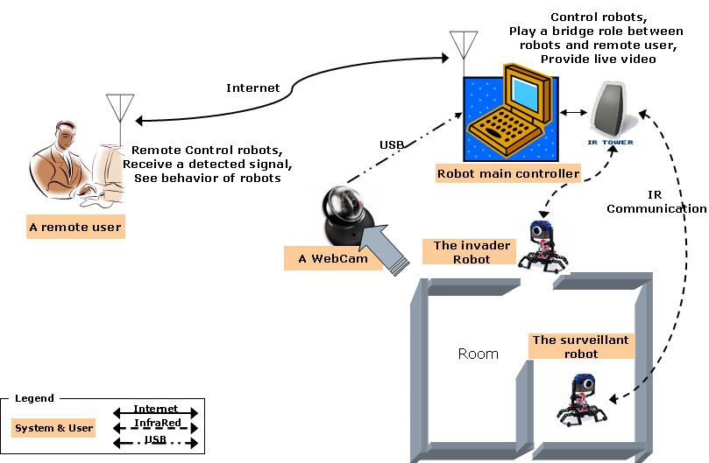
Figure 1 Overview of a Surveillant Robot System

