`4th Annual Different Color Hair Day

Wednesday 2 April 2003

Noon, Hamerschlag Hall Steps

Proceeds to be donated to the Children’s Hospital of Pittsburgh Foundation
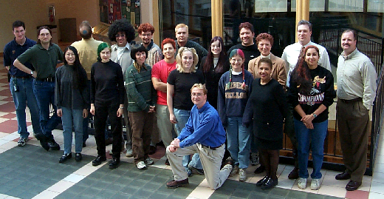

Sponsor Sign-up Form
Name, email, and phone  (print) | Signature | Pledge/ Head | Max Donation | Special Conditions
Prof. William Messner  dchd_cmu@yahoo.com  x82510 |  | $1 | $2003 | Will shave head for 500 participants
Complete a copy of this form and send it by campus mail or US Post (no email please) to

DCHD
c/o Prof. William Messner
Department of Mechanical Engineering, SH 307
Carnegie Mellon University
Pittsburgh PA 15213-3890
4th Annual Different Color Hair Day Sponsor Sign-up Form
Name, email, and phone  (print) | Signature | Pledge/ Head | Max Donation | Special Conditions
Send to: DCHD, c/o Prof. William Messner, Department of Mechanical Engineering, SH 307, Carnegie Mellon University, Pittsburgh PA 15213-3890

